E-Commerce and Online Shopping Platform
Visual workflow diagrams
These diagrams show the end-to-end customer checkout process and the internal order fulfilment process. They complement the written workflow descriptions in the project documentation.

1. Customer shopping and checkout
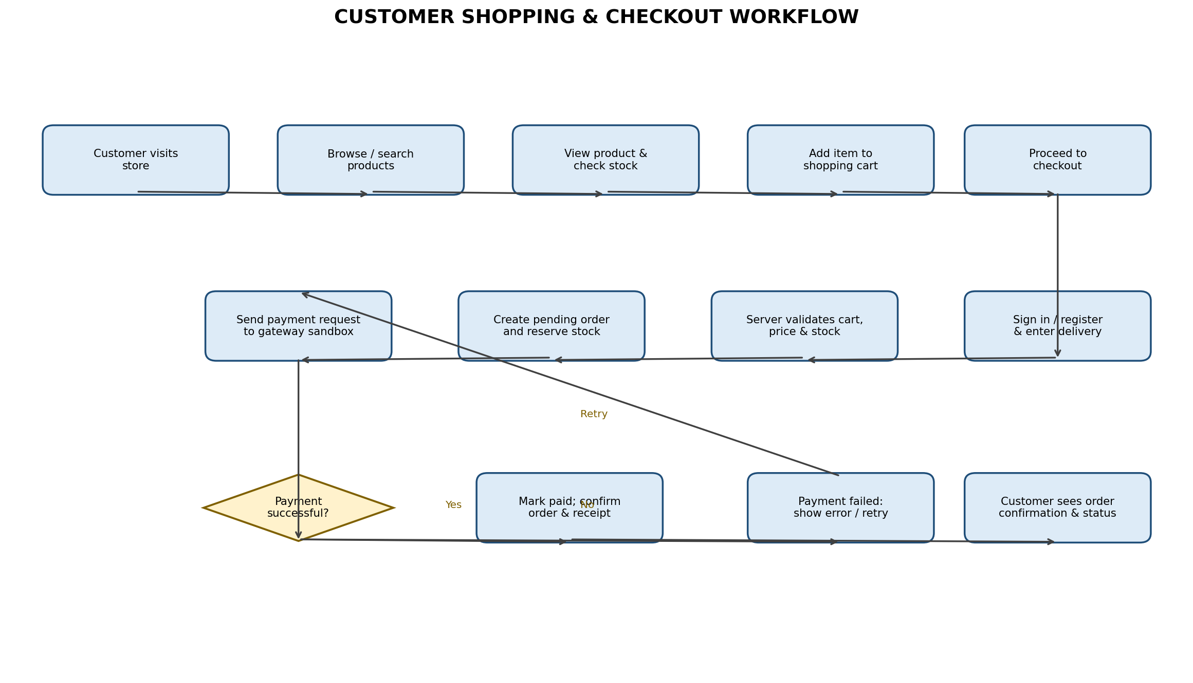
Key controls: the server recalculates prices and validates stock at checkout; payment is confirmed through the gateway response/webhook; failed payments remain unpaid and can be retried. Do not mark an order as paid solely because the browser displays a success message.

2. Order fulfilment, tracking and administration
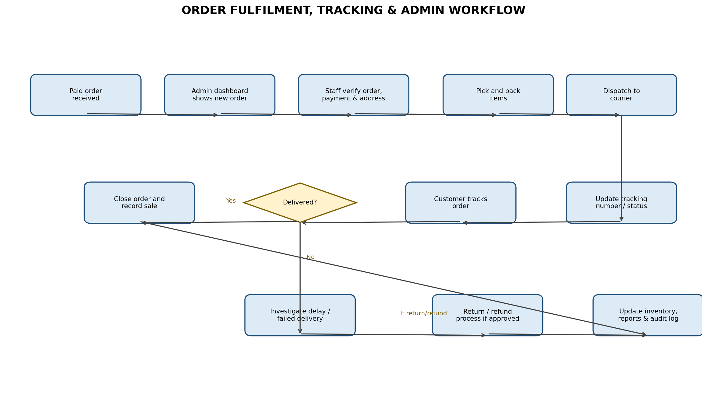
Key controls: only paid/approved orders proceed to fulfilment; staff update dispatch and tracking details; delivery exceptions are investigated; approved returns/refunds update inventory and financial records; all important changes are logged.

3. Simplified system interaction
- Customer browser (React.js) → Laravel REST API: registration, login, catalogue, cart, checkout and order tracking.
- Laravel API → MySQL: users, products, categories, stock, carts, orders, payments and audit records.
- Laravel API ↔ Payment gateway sandbox: payment initiation, verification and webhook notifications.
- Admin dashboard (React.js) → Laravel REST API: product management, inventory, order processing and sales reports.

